AppWork Tip

API定义

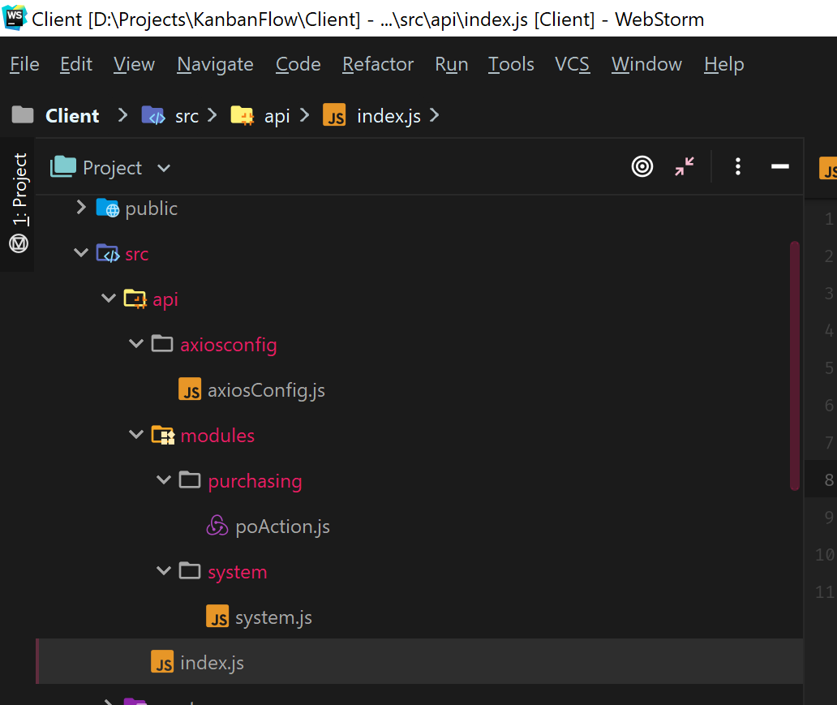­­­

*import* axios *from* 'axios';  
*import* poAction *from* "./modules/purchasing/poAction";  
*import* system *from* "./modules/system/system"  
*export default* {  
 */\*axios.create({  
 baseURL: 'http://reactify.theironnetwork.org/data/'  
 })\*/* poAction,  
 system  
}

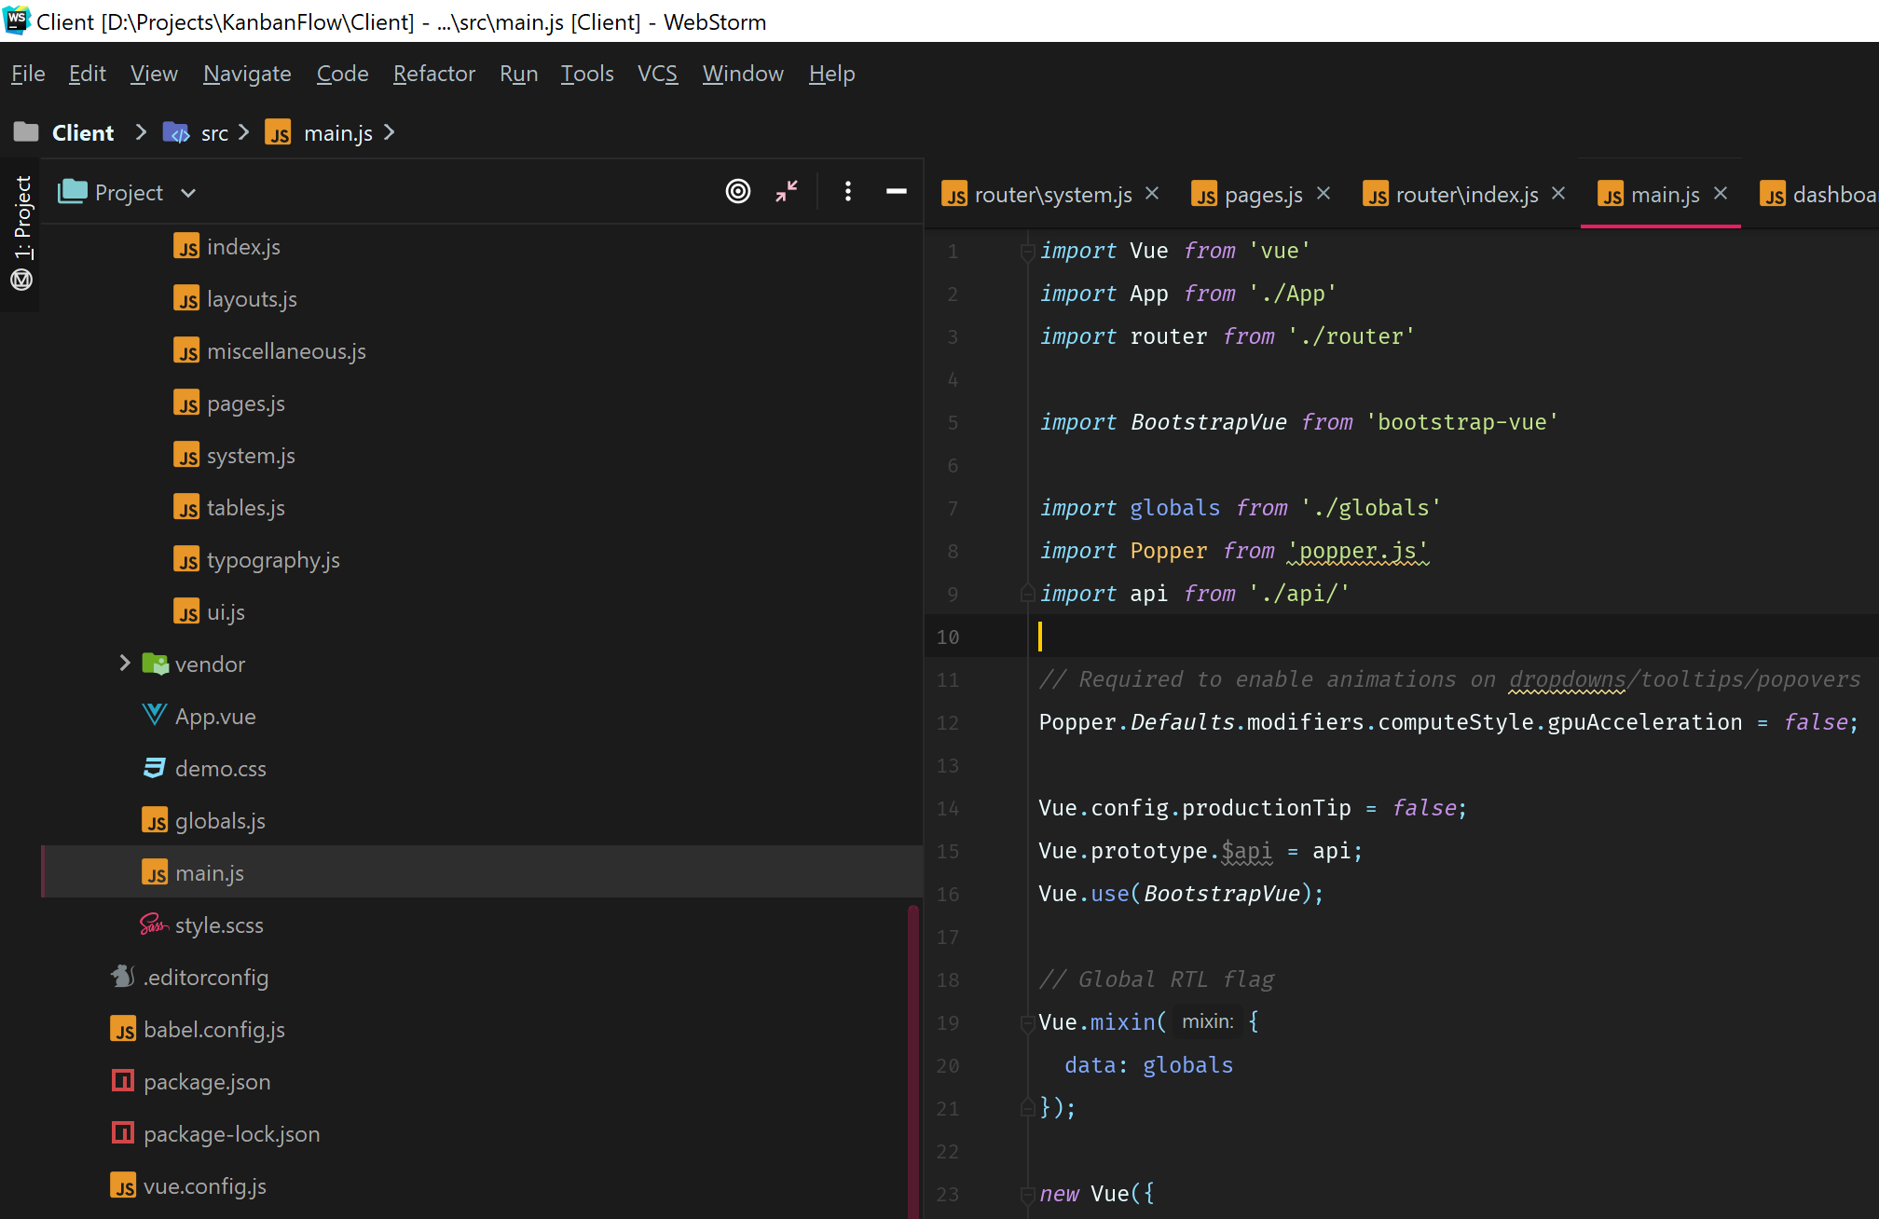

组件数据调用

<template>  
 <div>  
 <h4 *class=*"font-weight-bold py-3 mb-4">  
 Edit article  
 </h4>  
 <li *v-for=*"x in userList">  
 {{x.userName}}  
 </li>  
 </div>  
</template>  
  
<script>  
 *export default* {  
 name: "SysUser",  
 metaInfo: {title: "User Management"},  
 data: () => ({  
 userList: *null* }),  
 mounted() {  
 *this*.loadData();  
 },  
 methods: {  
 loadData() {  
 *this*.$api.system.getAllUsers().then((res) => {  
 *this*.userList = res;  
 }).catch(err => {  
 console.log(err);  
 });  
 }  
 }  
 }  
</script>  
  
<style *scoped*>  
  
</style>

路由

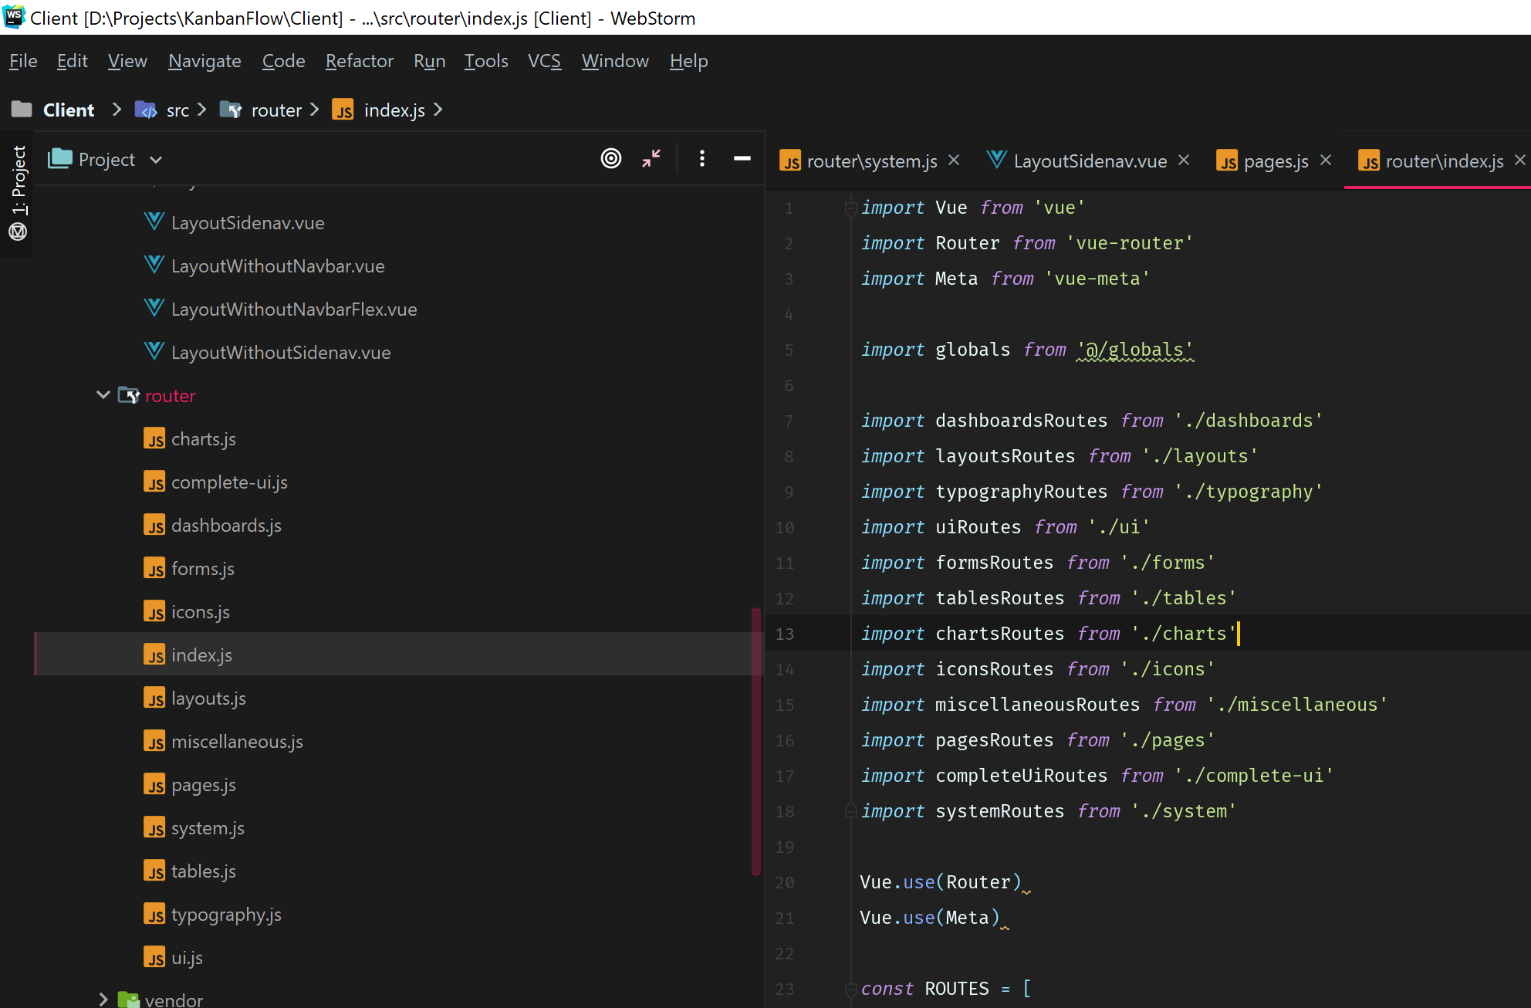

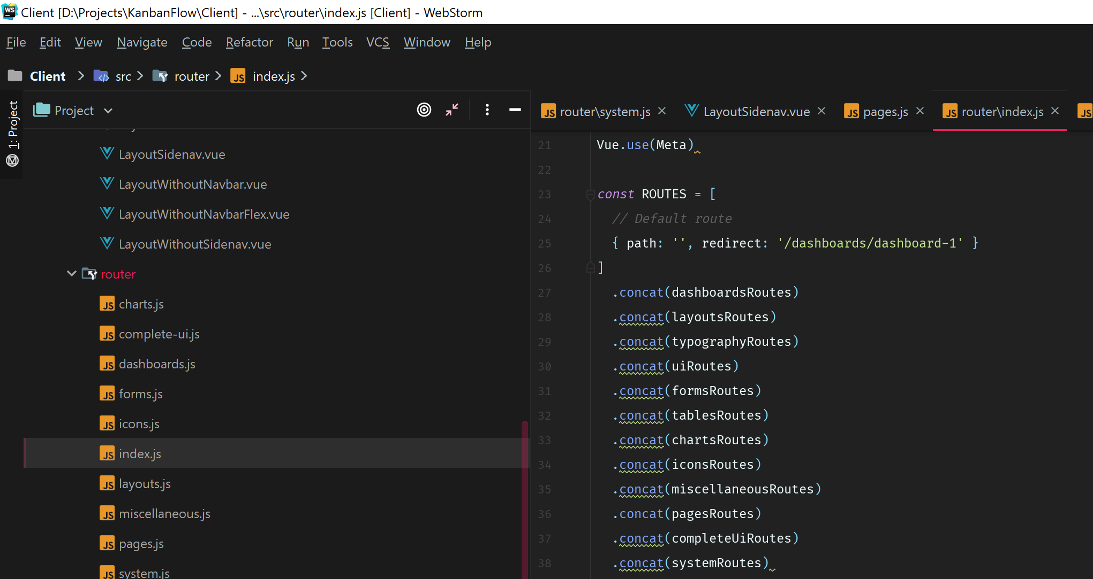

Form

<dx-item dataField="itemNo" editorType="dxTextBox"

:editorOptions="{ placeholder:'Enter item no...',readOnly:false}"

:label="{text:'Item No'}"

:visible="true">

</dx-item>

<dx-item dataField="description" :label="{text:'Description'}" editorType="dxTextBox"

:editorOptions="{ placeholder:'Enter description...',readOnly:false}"

:visible="true">

</dx-item>

<dx-item dataField="uom" editorType="dxTextBox"

:editorOptions="{ placeholder:'Enter unit of measure...',readOnly:false,onValueChanged:valueChanged}"

:label="{text:'Unit of Measure'}"

helpText="UOM"

:visible="true">

</dx-item>

Grid 行颜色改变

onRowPrepared(info){

if(info.rowType === 'data') {

let shift=info.data.shift===0?"日班":"夜班";

let shiftRange=utility.getVisibleRange(new moment().toDate(),shift);

let recCTime=moment(info.data.cTime);

if(recCTime.isBefore(shiftRange[0]))

{

if(info.data.seqID===12 || info.data.seqID===24){

info.rowElement.style.backgroundColor = "#26C281";

info.rowElement.style.color = "white";

info.rowElement.className = info.rowElement.className.replace("dx-row-alt", "");

}

}

else {

if(recCTime.isAfter(shiftRange[1]))

{

}

else{

/\* let curTime=moment(moment().format("YYYY/MM/DD HH:30:00"),"YYYY/MM/DD HH:mm:ss");

let curMinute=moment().minute();

if(curMinute<30){

curTime=curTime.add(-1,"hour");

}\*/

if(moment(recCTime).isSame(utility.getCurPeriodEnd()))

{

info.rowElement.style.backgroundColor = "#26C281";

info.rowElement.style.color = "white";

info.rowElement.className = info.rowElement.className.replace("dx-row-alt", "");

}

}

}

}

},

Grid Cell颜色改变

onCellPrepared(args) {

if (args.rowType === "data") {

if (args.data.modifiedColumns.length > 0) {

var log = JSON.parse(args.data.modifiedColumns);

for (var key in log) {

if (key === "modifiedBy") continue;

if (args.column.dataField === key) {

args.cellElement.style.backgroundColor = "#e7505a";

args.cellElement.style.color = "white";

}

}

}

}

},

DataGrid更新是附带全部字段

<dx-tree-list *:autoExpandAll=*"true"  
 *:data-source=*"dsSysRolePermission"  
 *:hover-state-enabled=*"true"  
 *ref=*"refSysRolePermissionGrid"  
 *:remote-operations=*{filtering:true,sorting:true}  
 *:row-alternation-enabled=*"true"  
 *:selection=*"{ mode: 'single' }"  
 *:show-borders=*"true"  
 *:show-column-lines=*"true"  
 *:show-row-lines=*"true"  
 *:focused-row-enabled=*"true"  
 *:column-auto-width=*"true"  
 *@cellPrepared=*"onCellPrepared"  
 *@rowInserted=*"onRowInserted"  
 *@rowUpdating=*"onRowUpdating"  
 *@selection-changed=*"onSelectionChanged"  
 *id=*"refSysRolePermissionGrid"  
 *key-expr=*"id"  
 *parent-id-expr=*"parentId"  
 *root-value=*"0"  
 *:height=*"setHeight">

onRowUpdating: *function* (e) {  
 *for* (*let* prop *in* e.oldData) {  
 *if* (!e.newData.hasOwnProperty(prop)) {  
 e.newData[prop] = e.oldData[prop];  
 }  
 }  
},